**Project Structure**

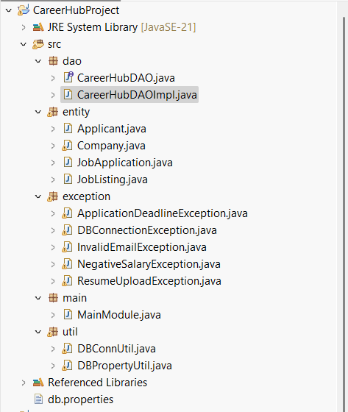

1.Create and implement the mentioned class and the structure in your application.

JobListing Class:

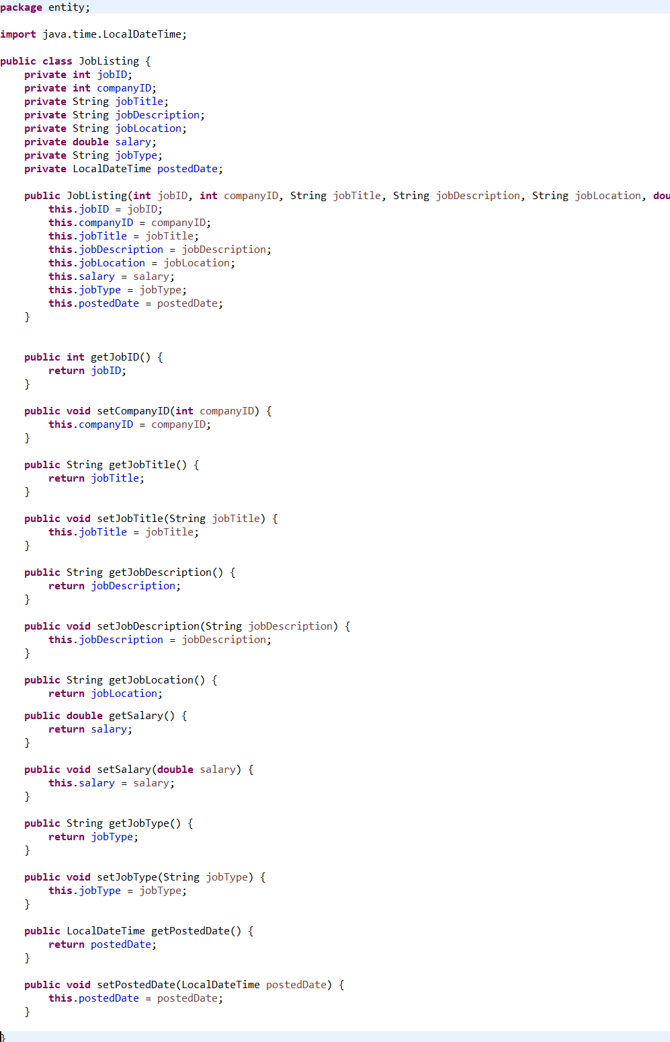

Company Class:

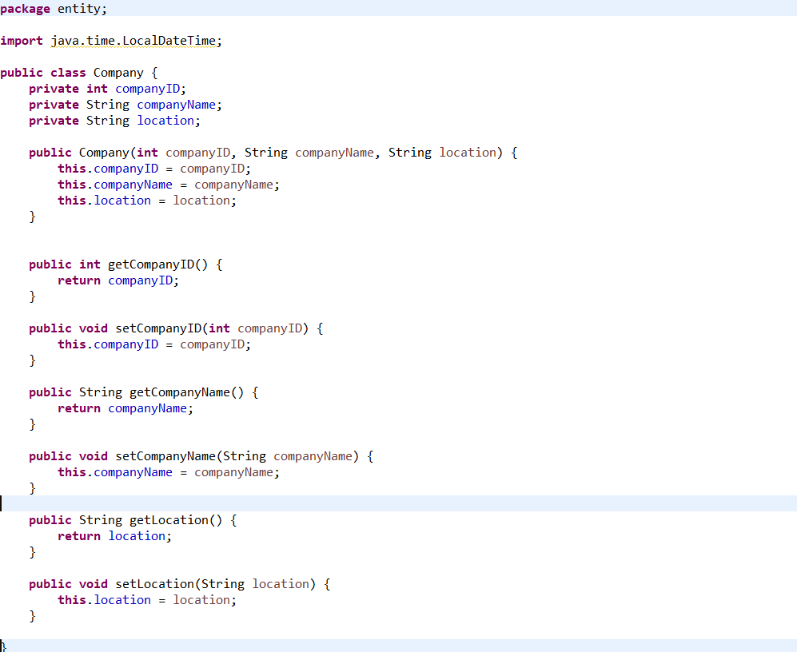

Applicant Class:

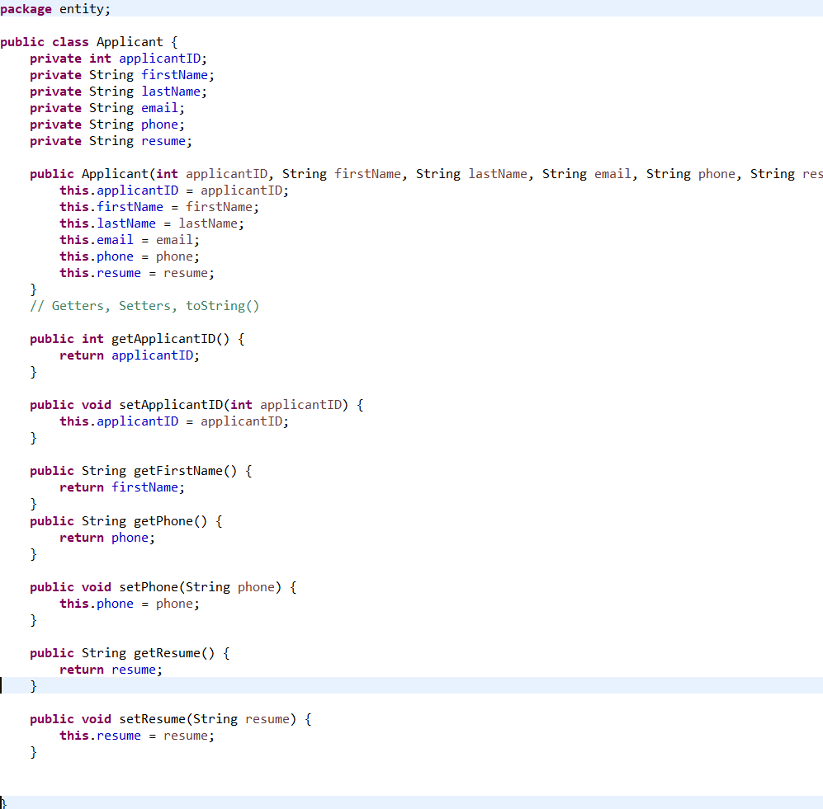

JobApplication Class:

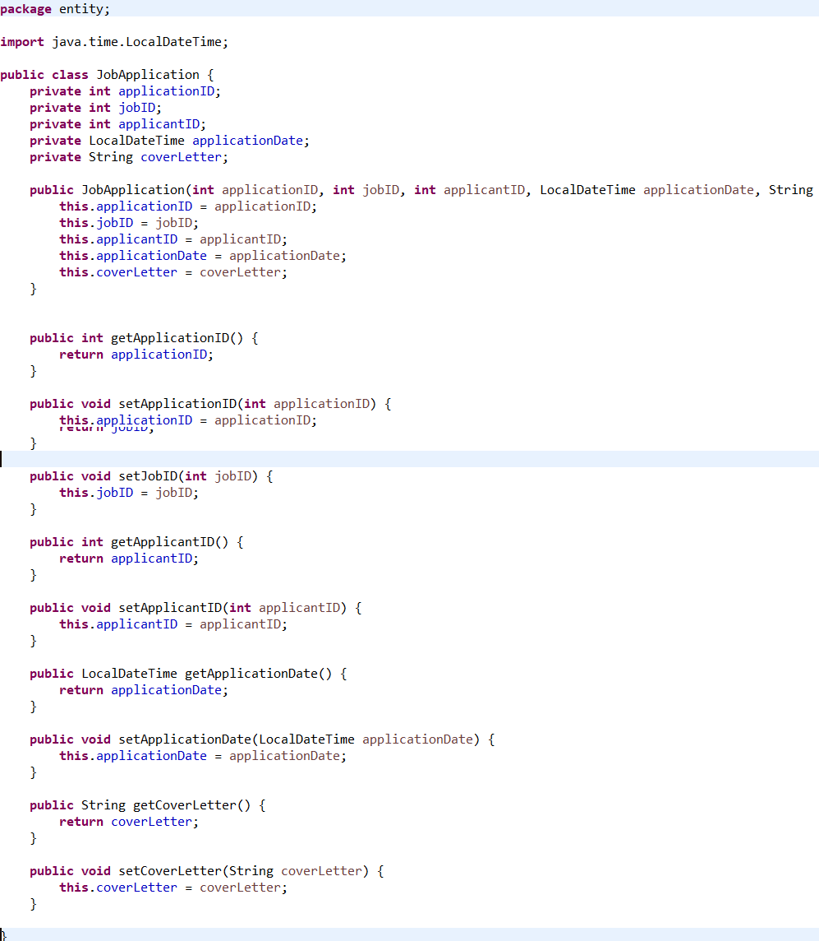

3.Exceptions handling

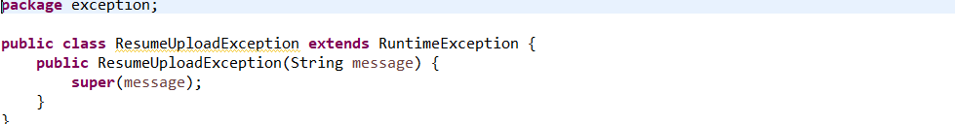

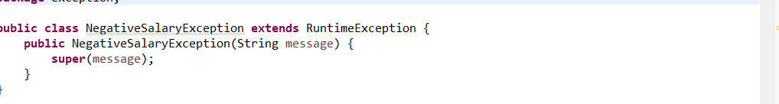

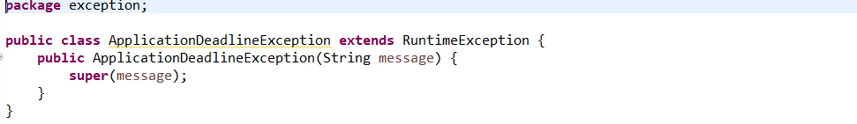

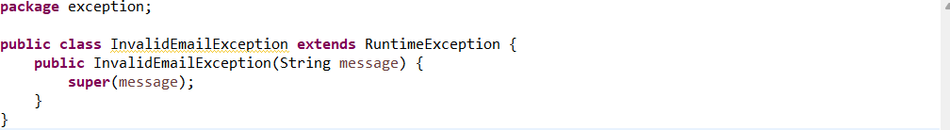

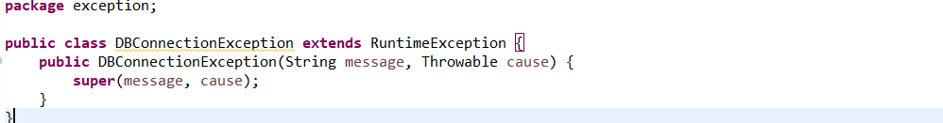

Tasks

Job Listing Retrieval:

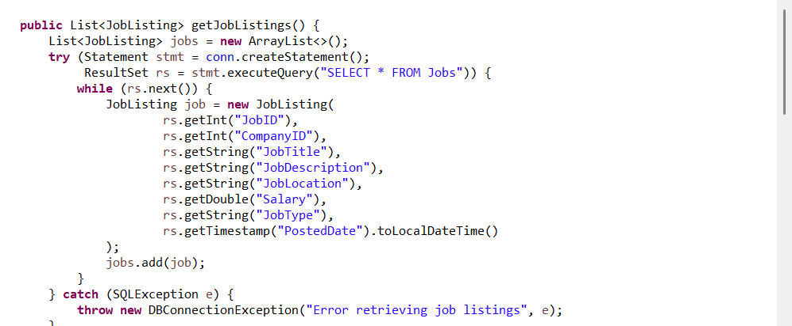

Applicant Profile Creation

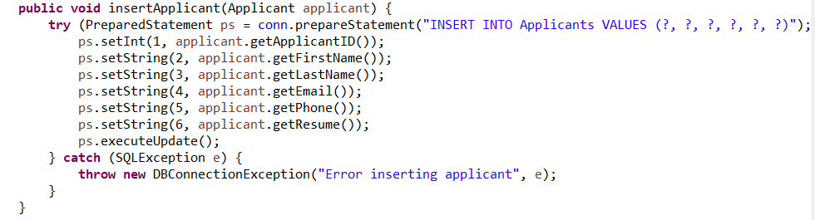

Job Application Submission

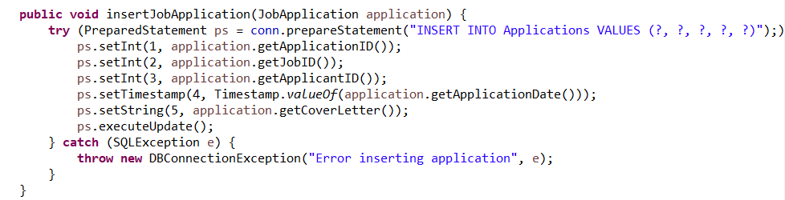

Company Job Posting:

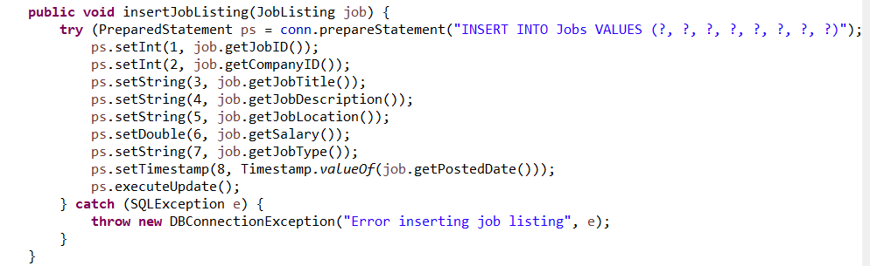

Salary Range Query:

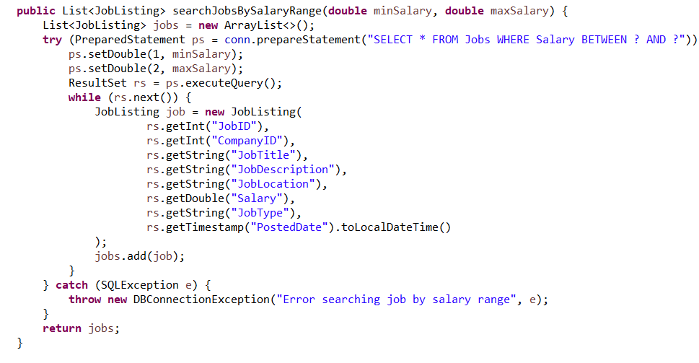

MainModule

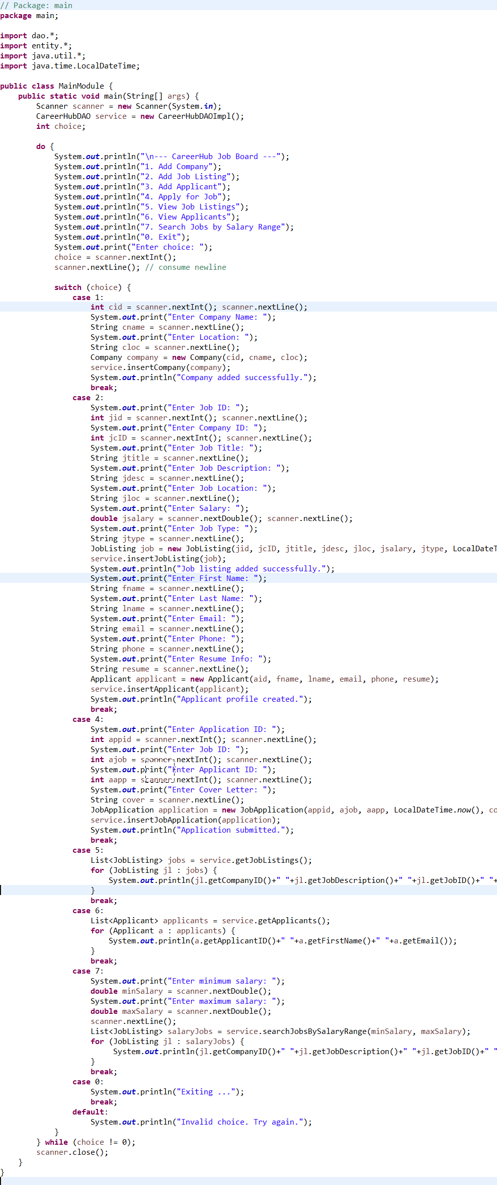

DBConnUtil.java

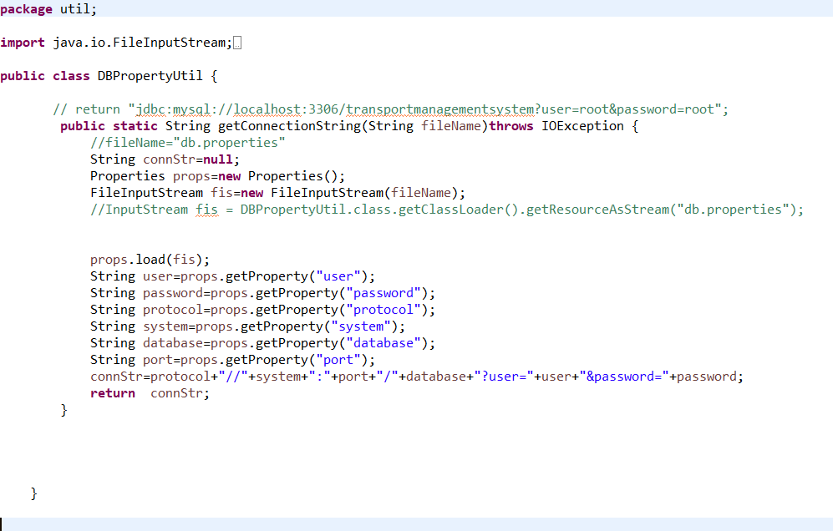

DBPropertyUtil.java

